EXPERIMENT 8
CONFIGURE ETHERNET SWITCH PORTS (ACCESS/TRUNK), AUTO/DUPLEX SETTINGS; OBSERVE LINK NEGOTIATION
NETWORK TOPOLOGY :
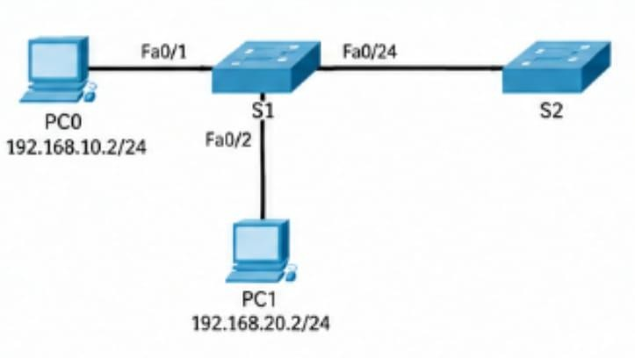
S1 CONFIGURATION ( ACCESS PORT – Fa0/1) :
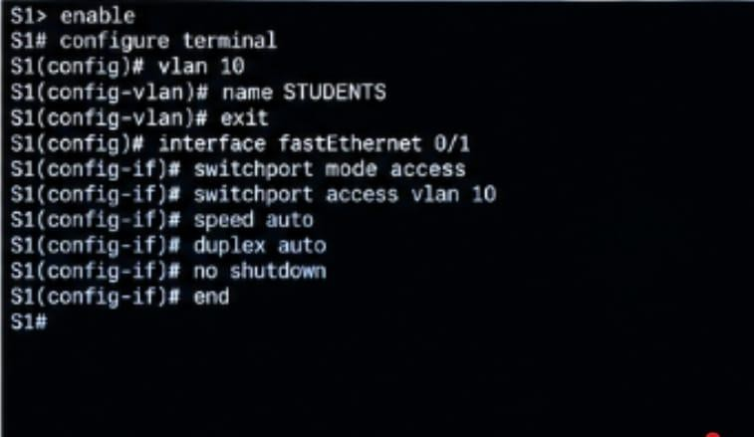

S1 – VLAN BRIEF & ACESS PORT STATUS :
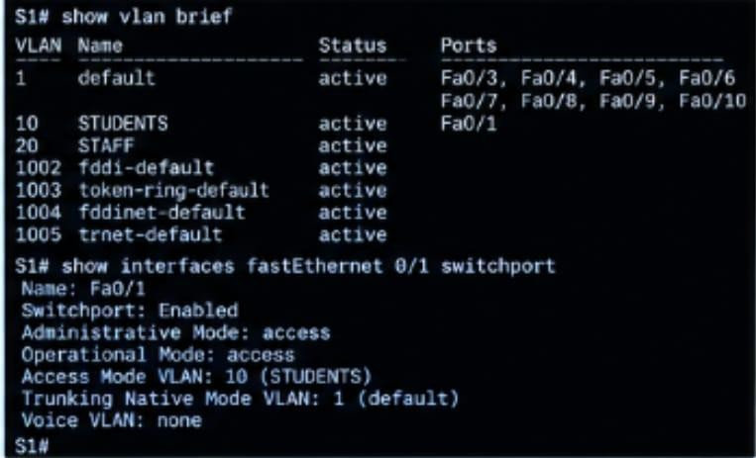
S1 – TRUNK PORT CONFIGURATION ( Fa0/24 ):
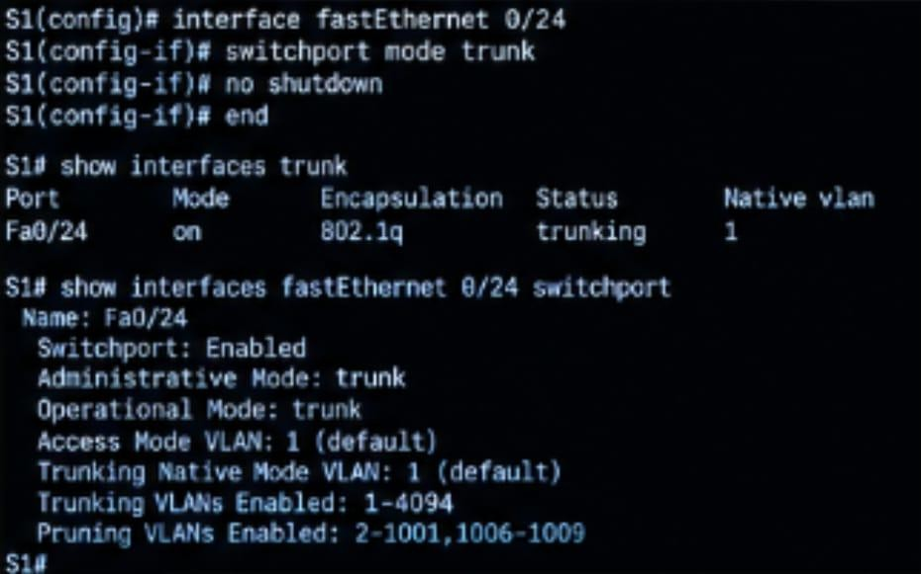

PING TEST :
